# The extent of the UK North-South divide

## Introduction

The North-South divide has received significant attention from both academics and policy makers since the beginning of the twentieth century (Martin, et al., 2015). This has mostly been focused on the economic divide that first was recognised during the inter-war period of the 1920s and 30s. As a result, there have been many different policies from many different governments since the Labour government of 1945 that have sought to reduce the divide (Gardiner, et al., 2013). However, the fact that it still remains an issue today points to the fact that such policy attempts have so far failed. One factor that has influenced this has been a lack of clear understanding of what the divide is, where it is and how this divide manifests itself in both economic and social indicators. Therefore, this essay seeks to further our understanding of the divide by comparing three different conceptions of the current North-South divide across multiple different indicators at the NUTS3 level.

## Literature Review

It is typically believed that the North-South divide started developing during the inter-war period of the 1920s and 30s. However, there is evidence to suggest that the history of the divide goes back much further than this to the 1850s (Martin, 1988). This is such that while the North was seen as the manufacturing powerhouse of England, it was subject to the whims of international trade cycles leading to high unemployment and low wages. Despite this, the divide only became a prominent issue in the 1920s and 30s as the global economic climate at the time consolidated and emphasised the differences between regions (Gardiner, et al., 2013). This included factors such as an adverse shift in Britain’s world trade position, restrictive domestic economic policies, and several recessions in the 1920s and 30s which imposed severe economic shocks on the industrial North (Gardiner, et al., 2013). At the same time the South did not suffer as much due to the development of advanced manufacturing in the region and greater levels of adaptation to the ‘new economy’ that was emerging at the time in services and finance (Armstrong & Taylor, 2000). These factors led to the Barlow report of 1940 which highlighted the imbalances, suggesting that the South acted as a serious drain on the rest of the country (Ward, 2010). Hence, the report advocated for a policy of spatial rebalancing including calls for funding to support the dispersal of industry across the country and restrictive development in and around London. Such ideas worked to inform the 1945 Labour governments introduction of a radical new regional policy system that was intended to promote a more balanced distribution of employment across the country (Gardiner, et al., 2013).

Since then there have been many attempts to tackle the North-South divide through a variety of mechanisms. In the last 50 years this has included shifts and changes in thinking and ideologies under different governments as to how to tackle this problem. The 1979 Conservative sought to tackle this divide through supply side policies aimed at tackling market rigidities and a perceived lack of entrepreneurship in some of the lagging regions. New Labour in 1997 then shifted this focus towards competitiveness at the regional level in both national and international markets, resulting in the conception of the Regional Development Agencies (RDAs) to try to boost regional economic growth. Then under the 2010 coalition government there was the scrapping of RDAs, the introduction of Local Enterprise Partnerships and the rise of the devolution agenda as continued under the 2015 Conservative government (Gardiner, et al., 2013). Therefore showing that each new successive government has often brought its own way of tackling the North-South divide.

The reason for such interventions comes from arguments based on both economic efficiency and social equity (Gardiner, et al., 2013). The former suggests that it is economically inefficient to have underutilised resources in slower growing regions as if they were fully utilised, they could boost overall economic growth. Furthermore, if economic activity was clustered in one region then competition would result in increased prices, harming international competitiveness, and increased congestion compared to the rest of the country (Gardiner, et al., 2013). The social equity argument however suggested that people’s opportunities should not be significant affected by where they live such that employment and income opportunities should be roughly equal across the country (Gardiner, et al., 2013).

To this end, the majority of research and policy intervention has been focused on economic indicators while failing to consider where exactly the divide lies. However, more recent research is beginning to explore the social dimension of the divide in terms of how this affects indicators that are suggested to be related to quality of life (Dorling, 2010). The main extension of this has been in health indicators as there is suggested to be significant disparities in health outcomes between the North and the South. For example, Bambra et al., (2014) p.1, suggest these disparities are similar to those seen between the ‘former West Germany and post-communist East Germany in the mid-1990s’ , with other papers finding similar extreme divides (Copeland, et al., 2014). This is now also extending into how geography affects factors and indicators such as voting patterns, seen in Johnston and Pattie (1989), and educational divides, as seen in Duranton and Monastiriotis (2001). This therefore suggests that the literature is beginning to explore and understand how this divide extends beyond economic measures such as gross value added or unemployment and the preliminary evidence suggests that it affects many facets of life.

As to the drawing of the dividing line however, Rowthorn’s (2010) paper is typical of how the existing literature tends to explore the divide. This is such that in his analysis he considers mostly economic indicators, draws no maps and looks at only the highly aggregated NUTS1 geography. In doing so he draws the dividing line from the River Severn to the Wash by separating Greater London, the South East, the South West, the East Midlands and the East from the rest of England, justifying this on the basis of availability of data, as seen in figure 2a. However, with increased sources of data, and at a more fine-grained scale, we are able to depict the divide with greater precision. This is exactly what Dorling (2010) does by focusing on measures that could be said to affect the quality of life in cities. As such, he draws the dividing line along the boundaries of Parliamentary constituencies, from the River Severn to south bank of the Humber, as seen in figure 2b. However, both of these were published in 2010, nine years ago, and many of these indicators have since changed. For example, a visual inspection of the gross value-added map in figure 1 suggests a more extreme divide between the area surrounding London and the rest of the UK which has been mapped onto figure 2c. This follows some recent commentaries in media outlets that draw the line between the prosperous South East and the rest of the country (Vassel, 2018).

## Research question

Therefore, the literature review above highlights the fact that traditional research has focused on the economic aspects of the North-South divide and has done so without a clear conception of where the dividing line may be drawn. This research therefore seeks to explore the questions of where the dividing line can best be drawn when considering social as well as economic indicators. This includes an exploration of dividing lines drawn by Rowthorn (2010) and Dorling (2010), along with the potential for a dividing line between the regions that surround London and the rest if the UK. This includes considering indicators such as education, life expectancy, the score of multiple deprivation and the percentage voting leave in the 2016 EU referendum.

## Methodology and data

The data used in this study comes from a variety of different departments and sources UK government website. This includes measures on: gross value added (GVA), unemployment, education, life expectancy, indices of multiple deprivation and the percentage voting leave in the 2016 European referendum. The issue with using such a variety of data was that these were mapped in different boundaries and at different scales. Therefore, these had to be transformed to the common geography of the European NUTS3 level to be able to compare and contrast the extent of the divide between the North and the South along the different conceptions of the dividing line.

The exploration of the extent of the divide was then undertaken using a simple linear regression analysis of the different indicators against a dummy variable. This dummy variable indicated whether a NUTS3 region was in the North or the South according to the ideas of Dorling (2010), Rowthorn (2010), and views that the South-East is separating from the rest of the UK as devised from a visual inspection of the map showing GVA against the UK average. These can be seen in Figure 2 a), b) and c). This allows for a comparison of the extent of the divide between the North and the South along different the dividing lines, and to compare their explanatory power for each of the indicators. To this end therefore, a 1 was assigned to a region if it was deemed to lie above the North-South dividing line.

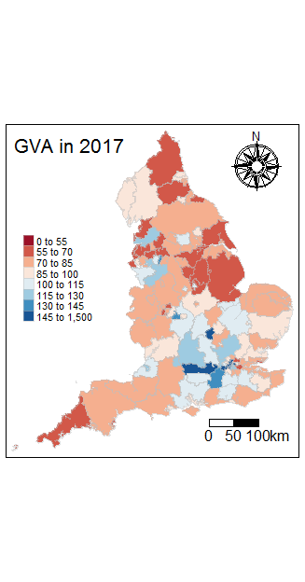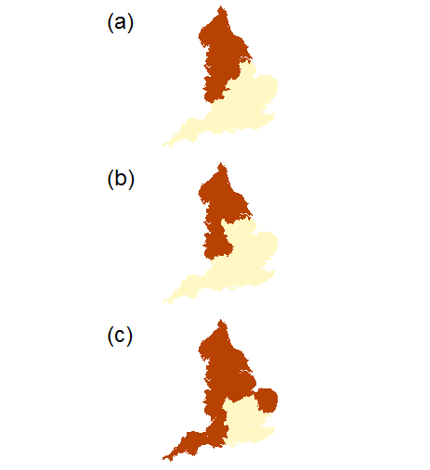

Figure 1 - UK GVA as a percentage of UK overall GVA Figure 2 - dividing lines in the UK

## Results

The mapped outputs showing the divide in terms of GVA can be seen in figure 1 whereas life expectancy, education, indices of multiple deprivation and the percentage voting leave in EU referendum can be seen in figure 3. For these, the middle of the diverging colour palette has been set as the average of the UK for that specific indicator. Based on these maps an initial visual inspection suggests that the divide in terms of social indicators does not appear as stark as that for GVA, although it does still appear that there is a divide. For example, in looking at figure 3a, the unemployment rate in 2018-2019 shows a pattern of high unemployment in London and along the east coast with no clear similarities to any of the divides in figure 2. In contrast female life expectancy appears to show a clear North-South divide as the majority of the above average life expectancies are in the South and the majority of the below average life expectancies are in the North. However, these visual inspections can be supported by references to the regression results seen in figure 4. These results show the expected fall or increase in the indicator by virtue of being above the dividing line and the extent to which being in the North or South can explain the variation in these indicators.

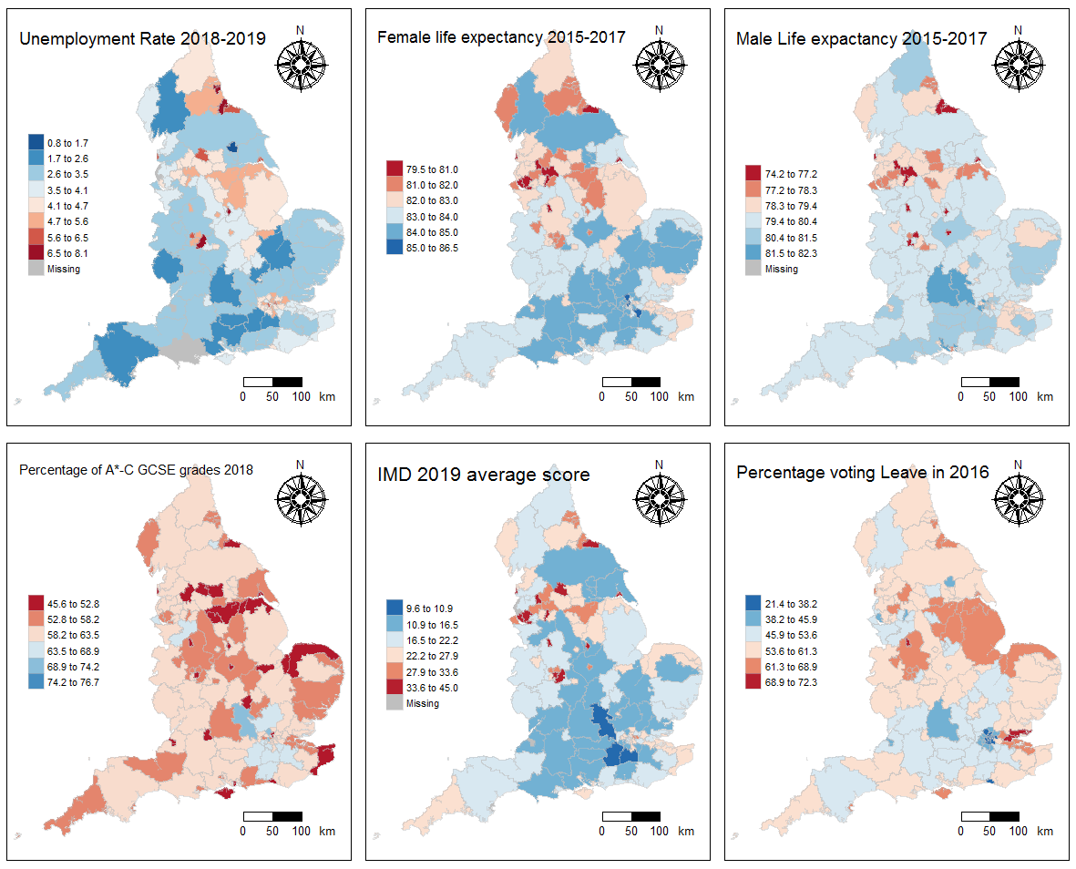

Figure - UK indicators mapped

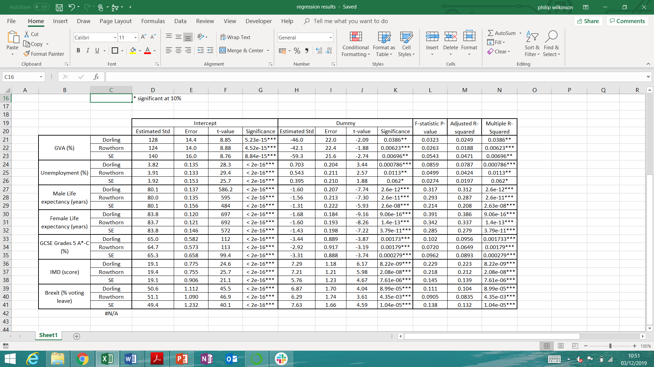

Figure - regression results

Firstly, considering the divide in terms of gross value added as a measure of productivity we can see that the dividing line envisioned by Dorling shows a larger gap than that by Rowthorn. This is such that moving from the North to the South under Rowthorn’s divide would result in a loss of GVA of 42.1% versus the UK average, while we see a loss 46.0% for Dorling’s dividing line. However, if we take the dividing line that separates London and its surrounding economies from the rest of the UK then this results in a fall in GVA from North to South on the magnitude of 59.3%. This therefore suggests that the South East is significantly ahead of the rest of the UK in terms of productivity and that the economic dividing line may indeed be between the South East and the Rest of the UK. However, these regressions have very low explanatory power as they only capture around 2 to 5% of the variance in GVA between regions and so this suggests that other factors are likely to influence this result.

However, in following Dorling’s (2010) example, other indicators must also be explored to determine the extent of the North-South divide. In doing so we first begin with the unemployment rate in 2018-2019. Using Dorling’s line suggests that moving above this line is associated with an increase in the unemployment rate of 0.70%, while the values for Rowthorn’s line and that focusing on the South East is 0.54 and 0.40% respectively. While these may appear as small values, given that the UK average was 4.1% then these suggests that being from the North or the South can mean a deviation of 10-20% from the UK average. However, again these have small statistical explanatory power for unemployment as they only explain 2-9% of the variation. A similar story can be said to be the case for educational indicators as Dorling’s line shows the greatest divide at a 3.44% decline in the percentage of A*-C grades at GCSE but with little explanatory power at 10%.

It is only when exploring life expectancy and indices of multiple deprivation do we see increases in explanatory power, although this is still relatively small. In terms of male and female life expectancy, Dorling’s divide shows the largest gap between the North and the South being associated with a decline in life expectancy of 1.60 and 1.68 years respectively. This is closely followed by Rowthorn’s line with a decline of 1.56 and 1.60, while that of the line between the South East and the Rest of the UK only shows a divide on the scale of 1.31 and 1.43 years. It is also with Dorling’s line that we see the greatest explanatory power as it is able to capture 31.7% and 39.1% of the variation in life expectancy. This suggests that there are significant divides between the North and the South in terms of health as whether you are living in the North or the South can explain over 30% of the variation in your expected life expectancy in the UK. A similar result can also be seen for the indices of multiple deprivation where again Dorling’s line shows a greater divide with an increase in score of 7.29 compared to a UK average of 22.2, this being able to explain 22.9% of the variation in the average indices of multiple deprivation score in England.

## Discussion

What these results therefore suggest is that there is a clear North-South divide in the UK and that Dorling’s line, running smoothly from the River Severn to the south bank of the Humber, shows consistently the greatest divide along multiple different indicators. This is such that crossing this line is associated with a decrease of 46% in GVA versus the UK average, an increase in unemployment of 0.70%, a decrease in male and female life expectancy by 1.60 and 1.68 years respectively, a decrease in the percentage of A*-C grades at GCSE of 3.44%, and increase in the indices of multiple deprivation score of 7.29, with the line being able to capture from 3-39% of the variation in these indicators. This therefore supports recent comments and research that suggest the economic divide is affecting other areas of life such as health and education (UKCES, 2011). Such a divide in terms of quality of life is likely to influence attitudes and behaviours, an example of which can be seen in the EU referendum results as being in the North is associated with an increase in the percentage of people voting leave of 6.87%. This is in line with previous findings that link geographical location with voting outcomes in elections (Johnston & Pattie, 1989), although it must be acknowledged that other factors also influence such outcomes, especially in the case of the EU refendum (Goodwin & Heath, 2016). However, such a result alludes to the fact that these divides along social and economic lines are likely to lead to backlash and unrest to some degree.

Furthermore, the fact that these divides remain after almost a century of policy intervention, asks the question of what are we doing wrong? To this extent, the literature suggests that the first step in the right direction is to acknowledge that the UK is one of the most politically and financially centralised countries in the OECD (McCann, 2016). This therefore restricts the ability of policies to acknowledge the challenges that places outside of London may face or provide the correct support to solve these problems. Therefore, some suggest that what is required is an institutional rebalancing across the UK to ensure that local decisions are able to maximise the return from resources provided to local governments (Martin, et al., 2015). To this end therefore the conservative government’s policy of devolution is taking a step in the right direction, but there remains a long way yet to go.

It must also be noted that there has been a consistent lack of clarity as to what rebalancing means, in terms of whether this is sectoral rebalancing, private versus public sector rebalancing or rebalancing of social indicators (UKCES, 2011). This is compounded by the fact that governments that have had a rebalancing agenda have often set multiple objectives, spreading resources too thin, and have often attempted to pursue economic and social objectives that often clash with each other (Armstrong & Taylor, 2000). This must therefore also be addressed to ensure that we are aiming towards the correct goals, along with ones that can actually be measured. Furthermore, we need to make sure that sufficient resources are provided both at a national and local scale so that initiatives can be fully implemented (National Audit Office, 2013). This can be seen in the case of the devolution agenda, which satisfies the move towards local policy decisions, but does not necessarily do so with the correct resources (Gardiner, et al., 2013).

## Conclusion

What is found is therefore is that Dorling’s (2010) delineation of the North-South divide shows the greatest differentiation between the North and the South across multiple different economic and social indicators and has the greatest explanatory power in terms of geography influencing these indicators. This shows that the divide manifests itself in many different ways and suggests that it could extend beyond the seven indicators used here. This has implications for both policy and academic research in that if we can clearly define the boundary between the North and the South we can see what factors affect this differentiation and then how policy can fix this. We can also speculatively consider how these divides may influence behaviours and views, as done here in exploring the 2016 referendum results. Ultimately, this suggests that policy must aim to tackle these divides to create a more cohesive England which is likely to result in both economic and social benefits for the entire country.

# Bibliography

Armstrong, H. & Taylor, J., 2000. *Regional Economics and Policy.* 3rd ed. Oxford: Blackwell.

Bambra, C., Barr, B. & Milne, E., 2014. North and South: Addressing the English health divide. *Journal of Public Health,* 36(2), pp. 183-186.

Copeland, A., Kasim, A. & Bambra, C., 2014. Grim up North or Northern grit? Recessions and the English spatial health divide (1991-2010). *Journal of Public Health,* 37(1), pp. 34-39.

Dorling, D., 2010. Persistent North-south Divides. In: N. Coe & A. Jones, eds. *The Economic Geography of the UK.* London: Sage, pp. 12-28.

Gardiner, B., Martin, R., Sunley, P. & Tyler, P., 2013. Spatially unbalanced growth in the British economy. *Journal of Economic Geography,* pp. 889-928.

Goodwin, M. & Heath, O., 2016. *Joseph Rowntree Foundation.* [Online]   
Available at: https://www.jrf.org.uk/report/brexit-vote-explained-poverty-low-skills-and-lack-opportunities  
[Accessed 5 December 2019].

Johnston, R. & Pattie, C., 1989. A Growing North-South Divide in British Voting Patterns. *Geoforum,* 20(1), pp. 93-106.

Martin, R., 1988. The Political Economy of Britain's North-South Divide. *Transactions of the Institute of British Geographers,* 13(4), pp. 389-418.

Martin, R., Pike, A., Tyler, P. & Gardiner, B., 2015. Spatially Rebalancing the UK Economy: Towards a New Policy model?. *Regional Studies,* 50(2), pp. 342-357.

McCann, P., 2016. *The UK Regional-National Economic Problem: Geography Globalisation and Governance.* 1st ed. New York: Routledge.

National Audit Office, 2013. *Funding and structures for local economic growth,* London: National Audit Office .

UKCES, 2011. *Rebalancing the eocnomy sectorally and spatially: an evidence review,* s.l.: UKCES.

Vassel, C., 2018. *Phantom Media.* [Online]   
Available at: https://phantom-media.co.uk/2018/10/a-divided-kingdom-a-brief-study-on-the-north-south-divide-in-british-culture-and-society/  
[Accessed 7 Decembet 2019].

Ward, M., 2010. *Rebalancing the eocnomy: prospects for the North,* s.l.: The Smith Institute.